Lab Exercise on Packages

# Question 1

Create a class **MATRIX** in a package called <<*yourname*>>. Include a read and print methods to input and output a matrix elements. This class should also include methods to add and subtract two matrices.

Create a TestMatrix class in a default package and let this class to access all the methods of the class MATRIX.

**CODE:**

**Package:**

package GokulJayan;

import java.util.Scanner;

public class Matrix

{

Scanner in = new Scanner(System.in);

int row, col;

int i,j;

int[][] ele;

public void read()

{

System.out.print("\nEnter row size: ");

row=in.nextInt();

System.out.print("Enter col size: ");

col=in.nextInt();

ele=new int[row][col];

System.out.println("Enter matrix elements: ");

for(i=0;i<row;i++)

{

for(j=0;j<col;j++)

ele[i][j]=in.nextInt();

}

}

public void print()

{

for(i=0;i<row;i++)

{

for(j=0;j<col;j++)

System.out.print(ele[i][j]+" ");

System.out.println();

}

}

public void add(Matrix M1, Matrix M2)

{

if(M1.row==M2.row && M2.col==M2.col)

{

row=M1.row;

col=M1.col;

ele=new int[row][col];

int i,j;

for(i=0;i<row;i++)

{

for(j=0;j<col;j++)

ele[i][j]=M1.ele[i][j]+M2.ele[i][j];

}

}

}

public void sub(Matrix M1, Matrix M2)

{

if(M1.row==M2.row && M2.col==M2.col)

{

row=M1.row;

col=M1.col;

ele=new int[row][col];

int i,j;

for(i=0;i<row;i++)

{

for(j=0;j<col;j++)

ele[i][j]=M1.ele[i][j]-M2.ele[i][j];

}

}

}

}

**TestMatrix:**

import GokulJayan.Matrix;

import java.util.Scanner;

public class TestMatrix

{

public static void main(String args[])

{

Scanner in = new Scanner(System.in);

int n, i;

Matrix m1 =new Matrix();

m1.read();

Matrix m2 =new Matrix();

m2.read();

System.out.println("\nMatrix-1:");

m1.print();

System.out.println("\nMatrix-2:");

m2.print();

Matrix m3=new Matrix();

m3.add(m1,m2);

System.out.println("\nSum:");

m3.print();

Matrix m4=new Matrix();

m4.sub(m1,m2);

System.out.println("\nDifference:");

m4.print();

}

}

**OUTPUT:**

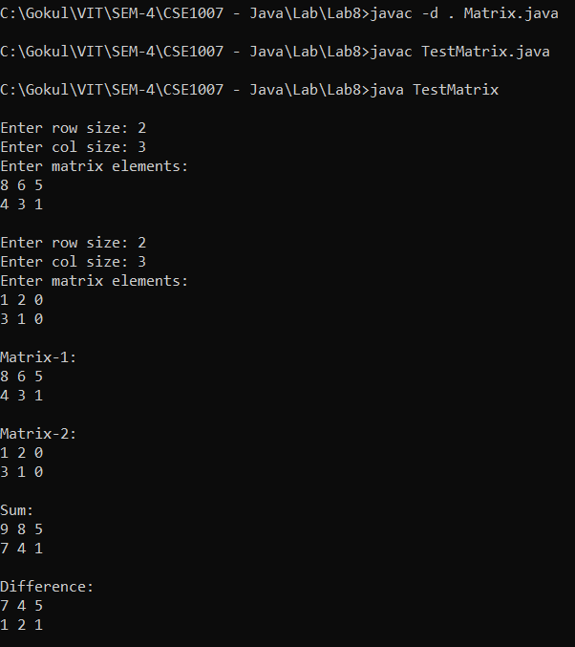

# Question 2

Consider the inheritance model given below.

Person

Staff

Patient

Doctor

Nurse

where each class is defined in a different package and the class **HospitalDatabase** has a list of patients, doctors and nurses defined in another package. This class should read and display the complete employee’s and patients data of the hospital.

**CODE:**

**Package-1 (Person)**

package pack1;

import java.util.Scanner;

public class Person {

Scanner in = new Scanner(System.in);

String Name;

int Aadhar;

public void getName()

{

System.out.print("Enter Name : ");

Name=in.next();

}

public void getAadhar()

{

System.out.print("Enter Aadhar No: ");

Aadhar=in.nextInt();

}

public void printName()

{

System.out.println("Name : "+Name);

}

public void printAadhar()

{

System.out.println("Aadhar No: "+Aadhar);

}

}

**Package-2 (Staff)**

package pack2;

import pack1.Person;

import java.util.Scanner;

public class Staff extends Person {

Scanner in = new Scanner(System.in);

int StaffID;

public void getStaffID()

{

System.out.print("Enter Staff ID : ");

StaffID=in.nextInt();

}

public void printStaffID()

{

System.out.println("Staff ID : "+StaffID);

}

}

**Package-3 (Patient)**

package pack3;

import pack1.Person;

import java.util.Scanner;

public class Patient extends Person {

Scanner in = new Scanner(System.in);

int PatientID;

public void getPatientID()

{

System.out.print("Enter Patient ID : ");

PatientID=in.nextInt();

}

public void printPatientID()

{

System.out.println("Patient ID : "+PatientID);

}

}

**Package-4 (Doctor)**

package pack4;

import pack2.Staff;

import java.util.Scanner;

public class Doctor extends Staff

{

Scanner in = new Scanner(System.in);

String Dept;

public void getDept()

{

System.out.print("Enter Department: ");

Dept=in.next();

}

public void printDept()

{

System.out.println("Department : "+Dept);

}

}

**Package-5 (Nurse)**

package pack5;

import pack2.Staff;

import java.util.Scanner;

public class Nurse extends Staff

{

Scanner in = new Scanner(System.in);

int Room;

public void getRoom()

{

System.out.print("Enter Room No: ");

Room=in.nextInt();

}

public void printRoom()

{

System.out.println("Room No: "+Room);

}

}

**Package-6 (Hospital Database)**

package packTest;

import pack3.Patient;

import pack4.Doctor;

import pack5.Nurse;

import java.util.Scanner;

public class HospitalDatabase{

public static void main(String[] args)

{

int i;

Scanner in = new Scanner(System.in);

System.out.println("Patients");

System.out.print("Enter no: of Patients: ");

int np=in.nextInt();

Patient P[]= new Patient[np];

for(i=0;i<np;i++)

{

P[i]=new Patient();

System.out.println("\nPatient-"+(i+1));

P[i].getName();

P[i].getAadhar();

}

System.out.println("\nDoctors");

System.out.print("Enter no: of Doctors: ");

int nd=in.nextInt();

Doctor D[]= new Doctor[nd];

for(i=0;i<nd;i++)

{

D[i]=new Doctor();

System.out.println("\nDoctor-"+(i+1));

D[i].getName();

D[i].getAadhar();

D[i].getStaffID();

D[i].getDept();

}

System.out.println("\nNurses");

System.out.print("Enter no: of Nurses: ");

int nN=in.nextInt();

Nurse N[]= new Nurse[nN];

for(i=0;i<nN;i++)

{

N[i]=new Nurse();

System.out.println("\nNurse-"+(i+1));

N[i].getName();

N[i].getAadhar();

N[i].getStaffID();

N[i].getRoom();

}

System.out.println("\n\nPatients' Details:");

for(i=0;i<np;i++)

{

System.out.println("\nPatient-"+(i+1));

P[i].printName();

P[i].printAadhar();

P[i].printPatientID();

}

System.out.println("\n\nDoctors' Details:");

for(i=0;i<nd;i++)

{

System.out.println("\nDoctor-"+(i+1));

D[i].printName();

D[i].printAadhar();

D[i].printStaffID();

D[i].printDept();

}

System.out.println("\n\nNurses' Details:");

for(i=0;i<nN;i++)

{

System.out.println("\nNurse-"+(i+1));

N[i].printName();

N[i].printAadhar();

N[i].printStaffID();

N[i].printRoom();

}

}

}

**OUTPUT:**



